**Project Reflections**

I reviewed data regarding regional and global unit sales for games published over the past 33 years. Overall, the data reflected my expectations. Proportionately there were strong North American sales throughout. Sales in the European Union have been increasing steadily and have overtaken Japanese sales.

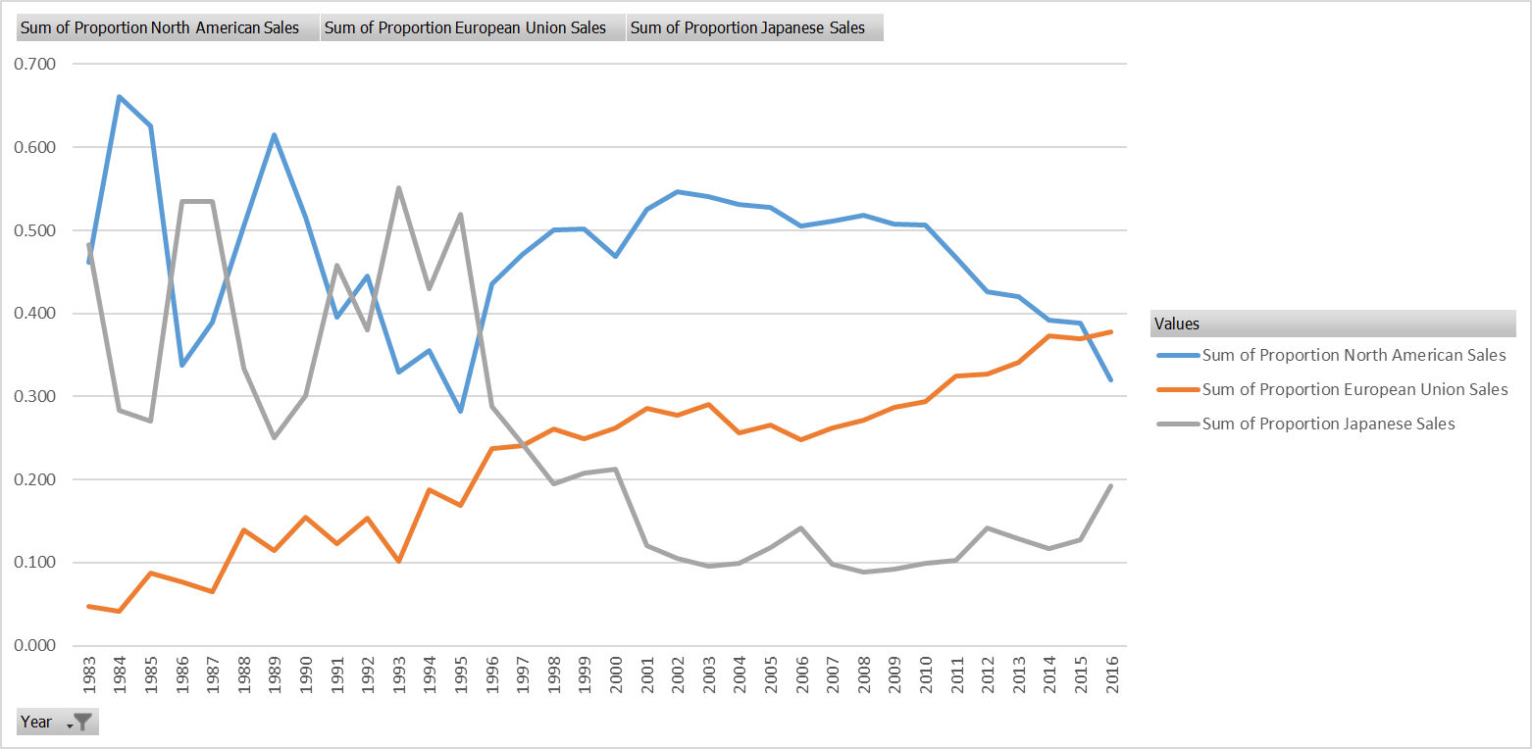

I noticed that EU unit sales even overtook North American unit sales in 2016, which surprised me. I looked at the actual data with Global Sales as a backdrop and found something even more surprising. The data showed that global unit sales have been declining since 2008:

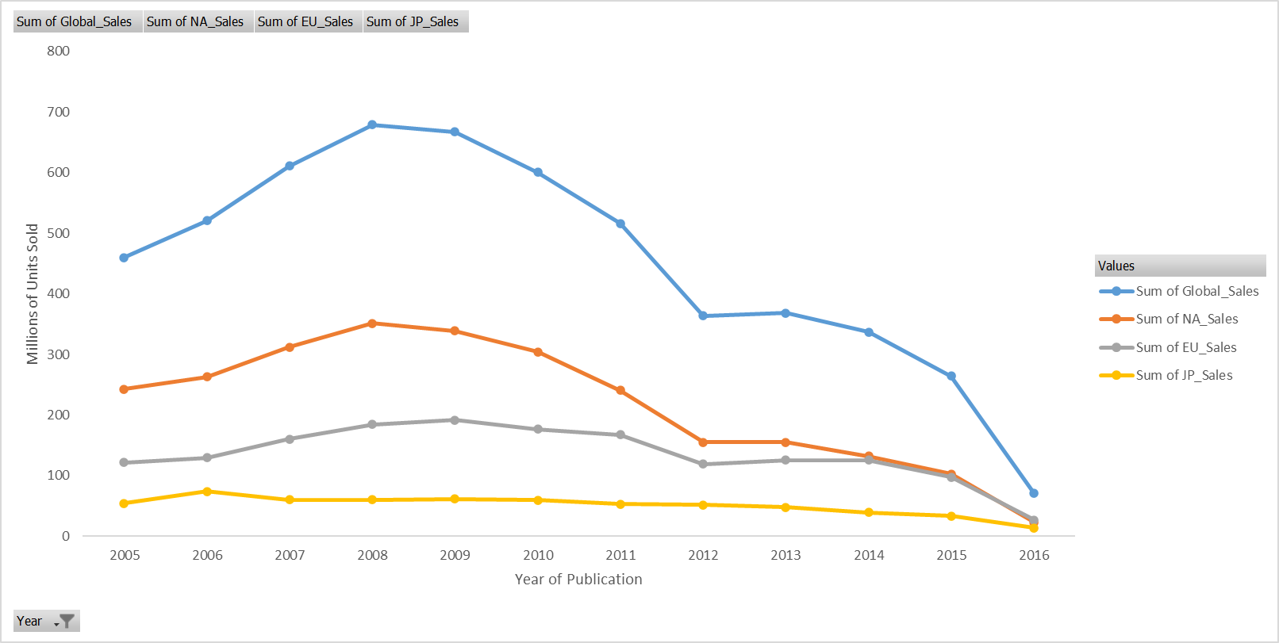

I did more research and found that our data provider listed some caveats regarding their data. The data does not accurately account for digital sales or downloads. Further, newer revenue generation models (free to play, subscriptions, etc.) are not reflected in the data.

I believe that our data can still provide valid trends for the relative strength of each regional market. I also believe that the decline in sales of physical media units informs GameCo of market and product chain opportunities that can be utilized to streamline and speed up production, eliminate or significantly reduce inventory costs and focus marketing efforts to make GameCo more profitable in 2017.

Technology has changed. The marketplace has changed. GameCo can take advantage of increased revenues and reduced expenses if we change with them.